Fundamentals of Neural Network Modeling Neuropsychology and Cognitive Neuroscience
edited by Randolph W. Parks, Daniel S. Levine, and Debra L. Long
A Bradford Book, The MIT Press
Cambridge, Massachusetts; London, England
1998

Chapter 2

Functional Cognitive Networks in Primates

J. Wesson Ashford, Kerry L. Coburn, and Joaquin M. Fuster

The information-processing capability achieved by the human brain is a marvel whose basis is still poorly understood. Recent: neural network models invoking par distributed processing have provided a framework for appreciating how the brain performs its tasks (McClelland, Rumelhart, & the PDP Research Group, 1986; Parks et al., 1989, 1992; Bressler, 1995). The concepts of parallel distributed processing developed in nonhuman primates provide useful models for understanding the extraordinary processing capa bility achieved by the human brain (Ashford, 1984; Goldman-Rakic, 1988). The field of neuropsychology can use this understanding to improve the capability of assessing specific human cognitive functions such as perception, memory, and decision making.
The nervous systems of nonhuman primates provide clues to the brain systems which support human cognition. Monkeys can learn sophisticated cognitive tasks, ai in doing so they use structural and functional brain sys tems highly similar to those used by humans. The functions of these systems are revealed through depth electrode recording of single or multiple neuro nal unit activity and event-related field potentials, and the anatomical dis tributions of the systems may be seen using high-resolution structural scanning and histological techniques. However, the neural bases of cognitive function become more dear when these techniques are applied in a context in which a specific neuropsychological function is occurring. For example, when neurons in a monkey’s visual association cortical region are observed to respond in the context of a visual memory task, the roles of both the neu rons in that region and the region as a whole neural network appear to fall into a comprehensible framework. In turn, models of information processing developed in regions of the nonhuman primate brain have direct applica bility to the function of analogous structures in the human brain (for reviews, see Fuster, 1995, 1997a,b).

BUILDING BLOCKS OF THE NERVOUS SYSTEM
Several basic principles of nervous system organization form the basis for
understanding higher primate brain function (Jones, 1990). The adaptive
sequence from sensation of the environment to initiation of reflexive movement is the fundamental operation that the nervous system provides. Neural pathways have developed redundant and parallel channels to assure the reliability and fidelity of transmitted information, as well as to increase the speed and reliability of processing. Neurons and neural networks also have developed means for abstracting, retaining, and later retrieving information—the basic time-spanning operations of memory. Progressively more complex levels of analysis form a hierarchy, with higher levels of neurons and networks performing progressively more complex information analyses and more refined response productions (Hayek, 1952). However, one general principle is: the more neurons involved in processing, the more complex the potential analysis of the information (Jerison, 1991). But a larger number of neurons also has a larger energy cost that must be borne by the organism and species, and hence a large brain must have a cost-benefit justification. Further, there is a need for both functional specialization (e.g., analysis of line orientation or color) and generalization (e.g., determining abstract relations between stimuli) of networks.

NEURONS AND NEUROTRANSMITTER SYSTEMS
The fundamental computational building block of the brain is the neuron, which contains dendrites for the input of information and an axon for the dissemination of the results of the neuron’s analysis. Typical invertebrate neural systems control muscle fibers by an excitatory acetylcholine neuron opposed by an inhibitory y-aminobutyric acid (GABA) neuron. In the vertebrates, acetylcholine neurons also work as activators throughout the nervous system, exciting muscle fibers and other effectors peripherally and activating numerous other systems centrally, including motor pacing systems in the basal ganglia and memory storage systems in the cortex. The GABA neurons of vertebrates presently are found only in the central nervous system where they still play the major inhibitory role from the spinal cord up to the cortex. Serotonin neurons appear to mediate sensitization conditioning in the invertebrate (Bailey & Kandel, 1995), and serotonin neurons, with the most widely distributed axons in the vertebrate brain, are retained in vertebrates for a variety of central functions which require a conditioning component (Jacobs & Azmitia, 1992). Similarly, catecholamine neurons developed in invertebrates, and play a role in reward-related learning in vertebrates (Gratton & Wise, 1988).
The principal neuron in the cerebral cortex is the pyramidal cell, which uses the amino acid glutamate as its neurotransmitter. Glutamate mechanisms are highly active in the olfactory system (Kaba, Hayashi, Higuchi, et al., 1994; Trombley & Shepherd, 1993), and play a role in the analyses of chemical stimulants. Olfactory functions include attending to and identifying a particular scent pattern, evaluating its significance, and retaining a memory
trace of the scent in its context. The major structural basis for information processing in the cortex may initially have developed in the olfactory sys tem to serve this function. Hence, glutamate neurons developed their central role in the cortex, perceiving and retaining sensory information and making decisions about approach responses in the olfactory system.
The olfactory system may be thought of as a long-range component of the gustatory system, and the interaction of olfaction and gustation can produce what is perhaps the most powerful form of learning. The olfactory system itself can mediate aversive learning, but it is not particularly powerful. Aversive learning mediated by the gustatory system, however, can be extremely powerful. A taste avoidance response can be conditioned in a single trial and is unusually resistant to extinction. The interaction of olfactory and gustatory systems is seen when odor and taste stimuli are combined; the taste-potentiated odor stimulus then acquires the same extraordinary one-trial conditioning and resistance to extinction as the taste stimulus (Coburn, Garcia, Kiefer, et al., 1984; Bermudez-Rattoni, Coburn, et al., 1987). Although these phenomena were discovered and have been studied in animals, both taste aversion and taste-potentiated odor aversion learning are seen in humans undergoing chemotherapy for cancer. They probably represent a very specialized form of learning in a situation where the organism must learn to avoid poisonous foods after a single exposure. Although taste-potentiated odor aversion conditioning is an extreme example of rapid acquisition, most odor conditioning appears to be acquired gradually over repeated trials. This form of associative conditioning may serve as an important mechanism of higher learning in the human cortex.
Another essential principle which appears to have originally appeared in the olfactory system is parallel distributed processing (Kauer, 1991). The mammalian olfactory epithelium contains sensory cells each of which has one of about one thousand genetically different odor receptors (Axel, 1995). The axons from these sensory neurons project into the olfactory bulb to terminate on the approximately two thousand glomeruli, with primary olfactory neurons expressing a given receptor terminating predominantly on the same glomeruli (Axel, 1995). However, environmental scents stimulate numerous specific olfactory receptors with different strengths, with each odor causing a spatially (Kauer, 1991; Shepherd, 1994) and temporally (Freeman & Skarda, 1985; Cinelli, Hamilton, and Kauer, 1995; Laurent, 1996) unique pattern of activity in the olfactory bulb which is broadly distributed. Thus, the olfactory circuitry converts an environmental chemical stimulus through a broad range of receptors into a complex pattern of activity in a large neuronal net work which is capable of recognizing approximately ten thousand scents (Axel, 1995). This pattern of parallel organization (Sejnowski, Kienker, and Shepherd, 1985; Shepherd, 1995) and broad distribution of activity (Freeman, 1987) serves as a template that is adapted by the cortex of the vertebrate mammalian brain.
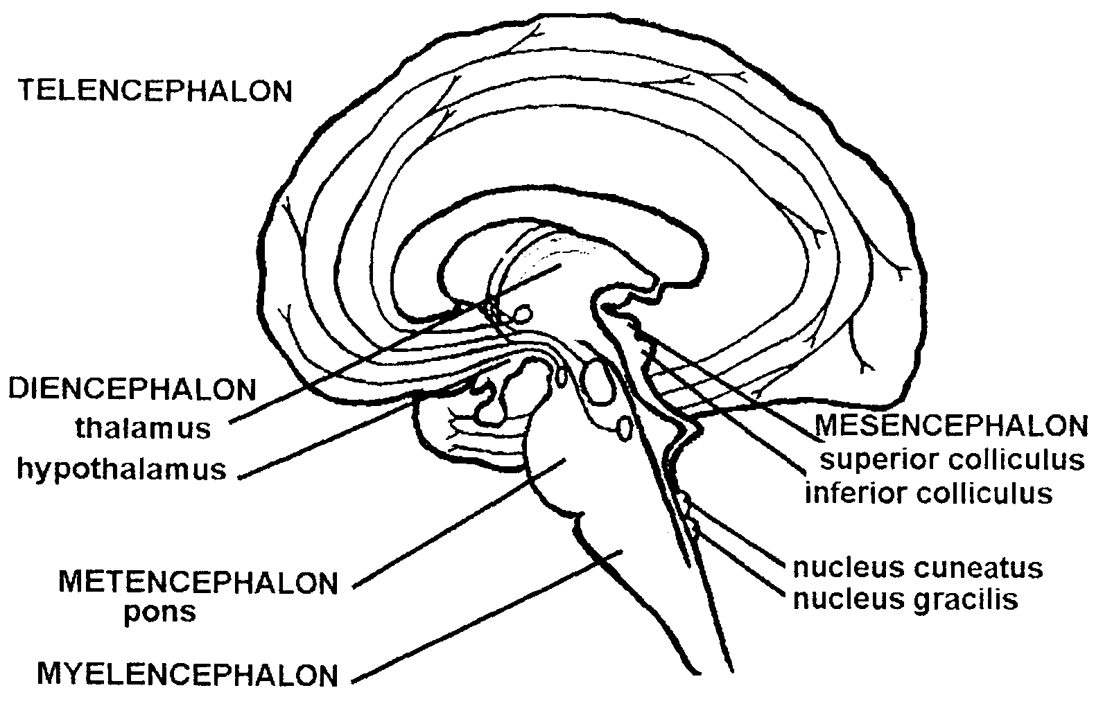
Figure 2.1 Fundamental components of the brain—telencephalon, diencephalon, mesencephalon, and metencephalon, and myelencephalon. For the brain stem, ventral is left and dorsal is right. The cerebellum is not shown.

VERTEBRATE BRAIN ORGANIZATION
Certain principles of vertebrate brain organization have been established, such as sensory analyses occurring dorsally, motor direction occupying a ventral position, and autonomic function lying in an intermediate position. Also, segmentation developed, so that local sensation led to local motor activation. A later development specialized the anterior segments for more complex analysis (Rubenstein, Martinez, Shimaniura, et al., 1994). In the vertebrate, the anterior five segments—the telencephalon (most anterior), diencephalon, mesencephalon, metencephalon, and myelencephalon—develop into the brain (figure 2.1), while the posterior segments become the spinal cord.
In the higher vertebrate brain there is a further specialization for sensory information analysis. The dorsal myelencephalon is specialized for somato sensory event detection (nucleus cuneatus for upper limbs and nucleus graci us for lower limbs) and the dorsal mesencephalon is specialized for auditory (inferior colliculus) and visual (superior colliculus) event detection. These structures receive information through large, rapid transmission fibers and, therefore, serve as sentinels to analyze the sudden occurrence of change in the environment. In contrast, the more anterior diencephalon (thalamus) receives information from these modalities along direct, separate, slower pathways for fine detail analysis.
Movement is regulated by several structures, including the metencephalic cerebellum, the ventral red nucleus and substantia nigra of the mesencephalon, and the basal ganglia of the telencephalon. The cerebellum gen erates fast ramp movements, while the mesencephalic nuclei and the basal ganglia pace slow ramp movements (Kornhuber, 1974). Accordingly, the brain divides motor activity functionally into fast ballistic movements and slow deliberate actions.
Throughout the vertebrate brain, autonomic function continues to be regulated intermediately between dorsal sensory systems and the ventrally connected motor systems. In the autonomic nervous system, several brain levels coordinate cardiopulmonary function, temperature regulation, and sleep. The anterior apex of the autonomic system is the hypothalamus in the ventral diencephalon. The hypothalamus is largely responsible for coordinating complex drives such as appetite, thirst, territoriality, and reproduction, and for fear and stress reactions. The hypothalamus is controlled in part by the amygdala, the frontolimbic loop (Nauta, 1971), and other telencephalic structures. A particularly important issue for the autonomic system is the conservation of energy, an issue relating to a variety of factors including ecological niche, sleep, predator/prey status, strategies for reproduction, and brain size (Berger, 1975; Allison & Cicchetti, 1976; Armstrong, 1983). The other sensory systems—visual, auditory, and somatosensory—have developed pathways into the cortex to take advantage of the information- processing power of this structure (Nauta & Karten, 1970; Freeman & Skarda, 1985; Karten, 1991; Shepherd, 1995). This invasion has also brought other neurotransmitter systems into the telencephalon to play a role in acti vation and information processing, including acetylcholine and GABA neurons, and projecting axonal processes from serotonin, norepinephrine, and dopamine neurons whose cell bodies lie in diencephalic, mesencephalic, and metencephalic structures (figure 2.2).

THE ROLE OF THE CORTEX IN INFORMATION PROCESSING
The medial temporal lobe structures in primates are considered nontopographically organized (Haberly & Bower, 1989; Kauer, 1991; Axel, 1995; Shepherd, 1995). These regions have no direct input from somatosensory, auditory, or visual systems, but do receive activating inputs from the brain stem and diencephalon.
In mammals, the lateral telencephalon developed a specialized structure with six lamina referred to as neocortex (Killackey, 1995), the principal structure in the primate brain for processing complex information. As other sensory systems have invaded the cortex, primary regions with specialized topographic organization have developed (somatotopic organization for somatic sensation, cochleotopic organization for audition, and retinotopic organization for vision). As the sensory systems established their primary

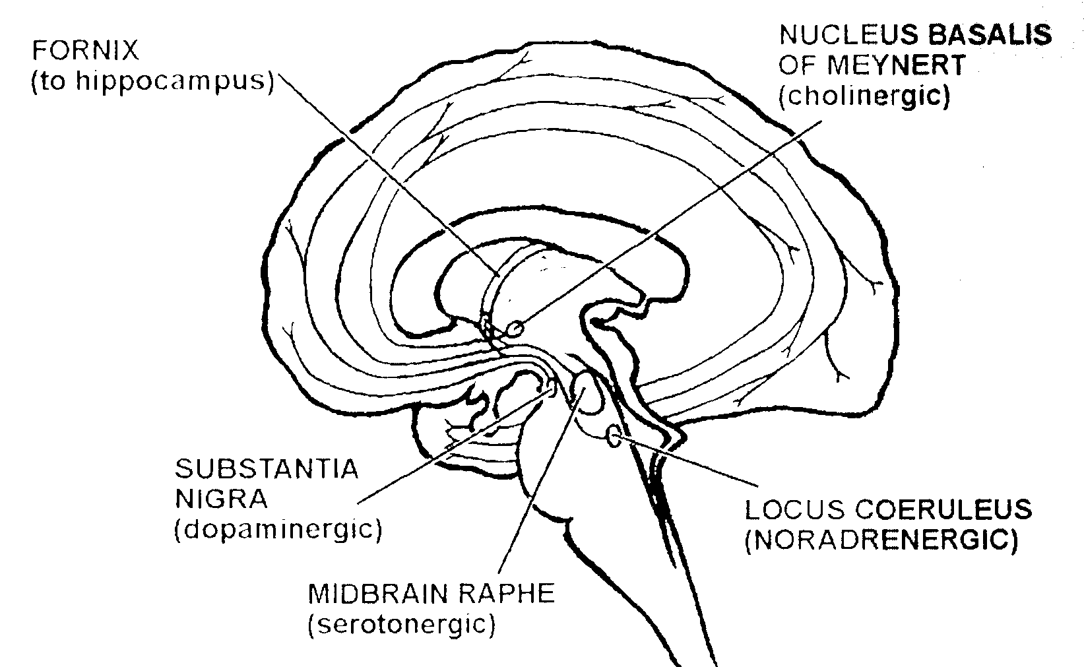
Figure 2.2 Neurotransmitter systems and projections from brainstem nuclei. Note that cholinergrc, noradrenergic, and serotonergic axons course upward through the fornix to the hippocampus.

entry regions behind the central sulcus, elaboration of the sensory processing regions pushed cerebral volume development posteriorly. As the sensory systems developed, they also established close relationships with the medial temporal lobe structures for the evaluation of the importance of sensory information to the well-being of the animal amygdala) and spatial categorization hippocampus) of information (figure 2.3). Somatomotor function invaded the neocortex just anterior to the central sulcus and in conjunction with the somatosensory region, which formed just posterior to this sulcus. Consequently, the primary motor cortex has a somatotopic organization which is closely coordinated with the primary somatosensory region. The somatomotor cortex established a close relationship with the basal ganglia caudate, putamen, globus pallidus for pacing and directing movements (fig ure 2.4. Elaboration of motoric activity for vocalization (Preuss, 1995), and presumably thought and planning (Matthysse, 1974) pushed cortical volume development anteriorly in primates with the prefrontal cortex coordinating with the nucleus accumbens for pacing speech and abstract thought. Thus, the neocortex of mammals plays a role in all sensory and motor function, the telencephalon expanding over the lower brain regions both anteriorly and posteriorly to accommodate the increased processing demands.
An important and long-standing controversy has addressed the question of information processing beyond the primary cortical regions. Though topographic organization has developed several levels of
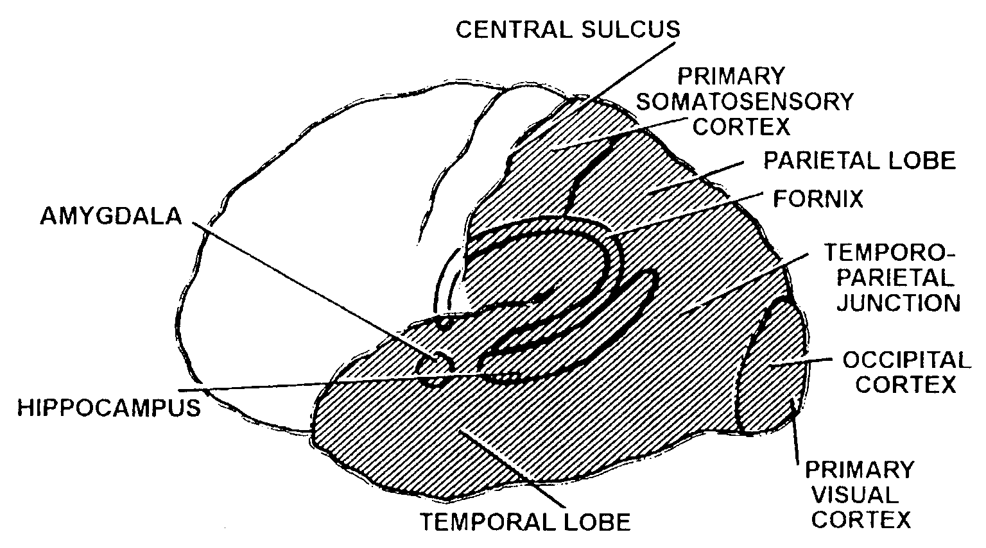
Figure 2.3 Posterior sensory, perception, and memory systems. The temporal, parietal, and occipital lobes process sensory information and are in bidirectional communication with the medial temporal lobe, including the hippocampus and amygdala. These regions also project to the basal ganglia but are probably less dominant in their influence on this structure than they are on the medial temporal lobe structures, or than the frontal lobe is on the basal ganglia.

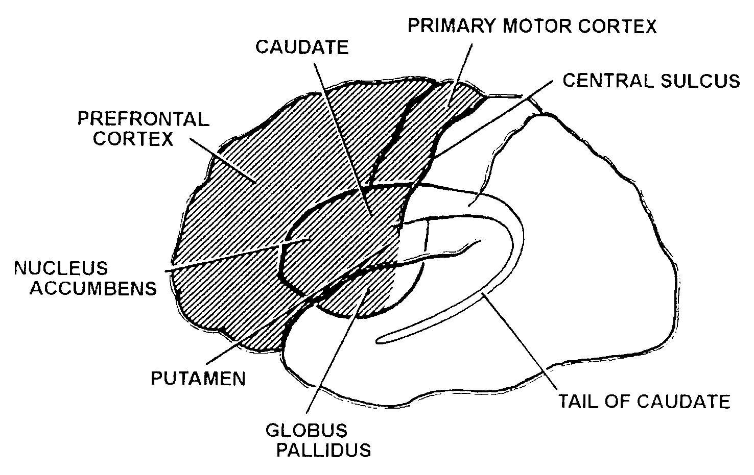
Figure 2.4 Anterior motor-, speech-. and thought-coordinating systems. The frontal cortex projects heavily into the basal ganglia, in particular the nucleus accumbens, which constitutes the large anterior portion of the basal ganglia. However, the frontal lobe seems to have less direct influence on the medial temporal lobe structures.
complexity in primary and secondary neocortical regions (Felleman & Van Essen, 1991; Van Essen, Anderson, and Felleman, 1992), large areas of the neocortex still seem to lack such organization, even as they have expanded to meet the processing demands of complex environmental niches (Lashley, 1950). For example, the temporal lobe has pushed anteriorly in primates to meet the need for more elaborate analysis of visual information (Ailman, 1990). Yet the anterior temporal lobe has no significant retinotopic organi zation (Desimone & Gross, 1979; Tanaka, Saito, Fukada, et aI., 1991; Tanaka, 1993; Nakamura, Mikami, & Kubota, 1994).
Important considerations for understanding information processing in the brain are timing and coordination. The primary thalamic nuclei relay detailed information to the primary sensory regions of the cortex. However, relevant broad cortical association regions are activated synchronously with the primary regions, presumably by the occurrence-detecting neurons of the brain stem acting through the pulvinar of the thalamus or by the reticular activating system (Moruzzi & Magoun, 1949), which includes ascending monoaminergic and cholinergic pathways and the reticular nuclei of the thalamus (Robbins & Everitt, 1995). Also, some modulation of input may occur through “efferent control” (Pribram, 1967). Cortical activation in response to a stimulus is evidenced by electrical field potentials recordable at the scalp. Following cortical activation and receipt of detailed information, analysis of stimulus particulars occurs in the cortex with reciprocal communication occurring between all of the activated cortical regions (for reviews, see Kuypers, Szwarcbart, Mishkin, et al., 1965; Ashford & Fuster, 1985; Coburn, Ashford, & Fuster, 1990; Ungerleider, 1995).

PRIMATE CORTICAL SENSORY, PERCEPTUAL, AND MEMORY SYSTEMS

Visual System
Many of the inferences regarding neuropsychological information processing in the human brain are derived from studies of the monkey. The most widely studied models involve the visual system. In primates, there is a unique crossing of retinal hemifields to both the contralateral superior colliculus and the primary visual cortex (Allman, 1982). Primary visual cortex is activated retinotopically by photic stimuli, and neurons are found there which preferentially respond to bars of light with unique orientations. These neurons are organized in slabs alternately serving inputs from the left and right eyes (Hubel & Wiesel, 1977). The monkey cortex contains at least twenty additional visual areas surrounding the primary visual cortex which are responsible for analyzing a variety of discrete aspects of visual information. Injury to a discrete area can cause loss of a specific neuropsychological analysis capability. The areas most closely connected to the primary visual cortex have a high degree of retinotopic organization, which diminishes at

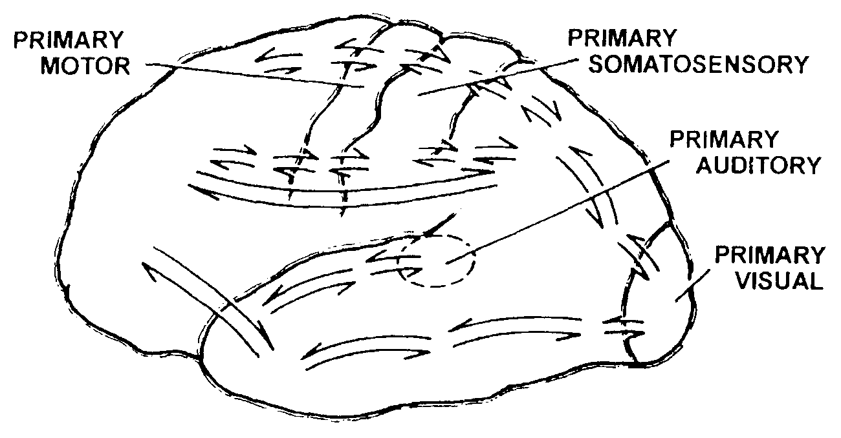
Figure 2.5 Information transmission between different regions of the brain. The dorsal and ventral pathways leading forward from the occipital cortex are shown connecting all the way to specific frontal cortical regions. Short and long fibers connect the sensory regions across the central sulcus. The auditory region’s connections with the temporal lobe are shown. Each of these regions has many other connections which are not shown.

higher organizational stages within the secondary visual areas (Felleman & Van Essen, 1991). Beyond the primary and secondary visual areas, retinotopic influence on neuronal responses becomes difficult to detect (Desimone & Gross, 1979; Nakamura et al., 1994). The alternative considerations are whether the specific pattern of analysis is yet to be determined or the mode of distributed processing provided by the olfactory model is utilized.
As processing proceeds forward from the primary and secondary visual areas, information is processed along two separate functional pathways (Ungerleider & Mishkin, 1982) (figure 2.5). One pathway leads ventrally toward the inferior temporal lobe. This ventral pathway abstracts such visual details as color, shape, and texture for identification of objects (Kuypers et al., 1965). In monkeys, a specialized region in the posterior inferior temporal region seems to play a role in the analysis of faces (e.g., Desimone, Aibright, Gross, et al., 1984; Mikami, Nakamura, & Kubota, 1994; Ungerleider, 1995), though the intensity of neuron response to faces in this region may simply indicate the general importance of face analysis, even in the monkey (Desi mone, 1991). So even in this unusual case, it is unclear whether an association region is specialized. Farther forward in the inferior temporal cortex, neurons respond to many stimuli (Desimone & Gross, 1979). At the anterior tip of the temporal lobe, neurons respond predominantly to abstract stimulus aspects (Nakamura et al., 1994), without any clear evidence of topographic organization, whether retinotopic, classificational, or otherwise. An important question regarding the nature of neuron responses along this path from primary visual cortex to the tip of the inferior temporal lobe concerns the selectivity of individual neurons for specific environmental items or characteristics. In the primary and secondary regions, individual neurons show a broad range of responses between high selectivity and nonselectivity (Van Essen & Deyoe, 1995). Inferior temporal neurons also have certain degrees of stimulus selectivity, but most neurons can readily be found to respond to one member of any limited set of stimuli, and neurons rarely show highly exclusive selectivity (Tanaka, Saito, Fukada, et al., 1991; Tanaka, 1993; Nakamura, Mikami, & Kubota, 1992; Nakamura et al., 1994). The range of selectivity in the inferior temporal cortex suggests that a stimulus which activates a neuronal field will elicit responses from many neurons rather than a few unique neurons, implying a broadly distributed analysis of information, a pattern of stimulus representation analogous to that of the olfactory system.
These findings concerning visual perception in monkeys are relevant to humans. However, in humans, there is clear evidence of hemispheric specialization. The left hemisphere is usually specialized by encoding verbal information. Regarding recognition of faces, Mimer (1974) found that in humans, right temporal lobe lesions interfere with the ability to remember faces and irregular line drawings, but did not affect memory for (perhaps easily ver bally encoded) geometric shapes.
The second visual pathway leads dorsally from the secondary visual cortex toward the parietal cortex and is responsible for analysis of spatial relationships. In the dorsal pathway, spatial analysis of visual information is performed in conjunction with posteriorly projecting connections from the somatosensory cortex which monitors the animal’s own position. Both animals and humans show deficits in learning tasks requiring perception of the body in space, following lesions of the posterior parietal cortex. In humans, body image and perception of spatial relationships are often severely abnormal following parietal injury.
In addition to the two specific visual pathways described above, project ing from the retina to the primary visual cortex and then anteriorly, neurons at all levels of the visual cortex receive activating input from the pulvinar (e.g., Benevento & Rezak, 1976; Macko, Sarvis, Kennedy, et al., 1932). The pulvinar, receiving visual information from a rapid retinal projection through the superior colliculus, activates the visual cortex broadly, priming neurons at all levels of both visual pathways to analyze informational details arriving through the retinal geniculostriate pathway.
Neurons of the inferior temporal visual cortex are sensitive to behavioral state, including attention (Maunsell, 1995). Neurons in this region have a substantial background level of activity, respond to stimuli with approximately the same latency as the neurons of the primary visual cortex, and remain elevated in the level of activity for several hundred milliseconds folowing visual stimulation (Ashford & Fuster, 1985). Further, they respond differentially to stimuli presented as a repetition after less than two intervening stimuli (Baylis & Rolls, 1987). While neurons in this region can be classified to some extent according to the range of objects to which they respond (Bayliss, Rolls, & Leonard, 1987), the selectivity of different neurons’ responses to a wide variety of stimuli can vary considerably (Nakamura et al, 1992, 1994). Nearly half of the neurons in the inferior temporal region will respond to one of two simple visual stimuli in the context of a behavioral paradigm which requires attention to each stimulus when it is presented (Ashford & Fuster, 1985; Coburn et al., 1990) (figure 2.6). This suggests the existence of an extensive functional neural network (ensemble) comprised of roughly half the inferior temporal neurons, within which analysis of the behaviorally relevant stimulus takes place. The 50 percent response rate is a level which mathematically allows the most powerful analysis of any stimulus (John, 1972; Coburn et al., 1990). The lower limit of the response rate would be one neuron responding to a single environmental configuration, requiring a unique neuron for each configuration. Clearly, this situation is an inadequate explanation and even a small number of responding cells could not provide adequate information-processing power to account for information encoding (Gawne & Richmond, 1993; Singer, 1995b). To achieve maximal encoding capability, the optimal response level is 50 percent of neurons in a field being activated by an environmental stimulus. Higher proportions would give lees power, as do smaller proportions. Approximating a transient 50 percent response rate would also allow cortical modulating processes to ensure maximal distribution of processing across cortical regions, while maintaining stability of neuronal excitation (figure 2.7). Further gradation of neuronal responses, for example by modulation of response frequency, would provide additional analytic power.
An important issue in the mode of information analysis of environmental events in the cortex is the nature of the temporal sequencing of the analytic processes. Early anatomical investigations suggested that information processing was serial, following the hierarchy from primary to secondary to association regions of the cortex. The presumption was that processing at each level took some finite amount of time before the results of that processing could be relayed to the next higher level. However, the discovery of reciprocal anatomical connections (Kuypers et al. 1965; Rockland & Pandya, 1979) simultaneously supported the concept of efferent control along the visual cortical hierarchy (Pribram, 1967). Thus, it became apparent that information processing could involve reciprocal communication along the identified processing pathways, even as far as the medial temporal lobe (Mishkin & Aggleton, 1981). When concurrent processing was discovered at the initial and terminal ends of the ventral visual cortical pathway (Ashford & Fuster, 1985) (see figure 2.6), and as far as the hippocampus (Coburn et al., 1990), the notion of simultaneous hierarchical processing was introduced, suggesting that quite complex methods of analysis were possible, including parallel distributed processing.
Individual neuronal responses are organized into temporally brief bundles (Ashford & Fuster, 1985), which have a statistical distribution (Bair, Koch, Newsome, et al., 1994). Additionally, some information may be encoded in the temporal structure of the spike trains (McClurkin, Optican, Richmond, et al., 1991; Eskandar, Richmond, & Optican, 1992; Ferster & Spruston, 1995; Singer & Gray, 1995), or spatiotemporal firing patterns (Abeles, Prut, Bergman, et al., 1994; Singer, Engel, Kreiter, et al., 1997). However, reciprocal information transfer forward and backward across numerous cortical processing stages (see figure 2.5) is probably required for memory storage (Rolls & Treves, 1994), and can include coherent neuronal activity occurring across widely distributed sites (Bressler, Coppola, & Nakamura, 1993; Bressler, 1995).

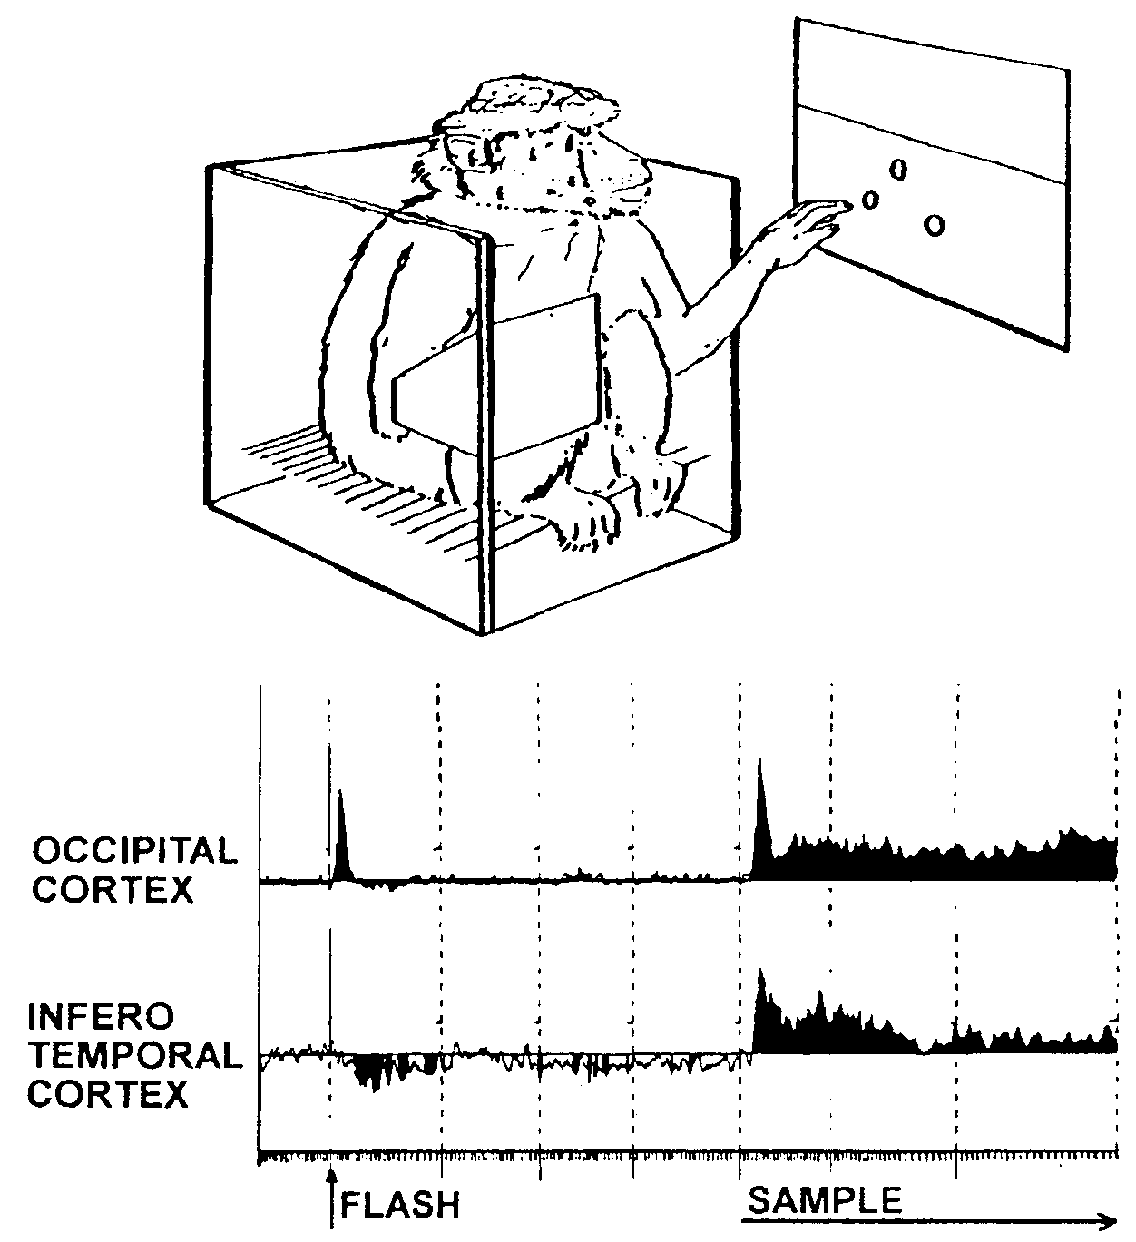

Figure 2.6 Monkey performing delayed match-to task (Ashford, 1934; Ashford & Fuster, 1985). In this task, after a 20-second waiting period, a flash from the upper stimulus panel illuminates the monkey’s visual field. Exactly 2.0 seconds later, the top button of the triangle is illuminated either red or green. The monkey must not touch any of the three stimulus buttons for at least 0.5 second prior to the flash, until the top stimulus light is illuminated. Then the monkey must press the top button for the trial to continue. The light is darkened after 1.5 seconds, then the monkey must wait 10 seconds for the two lower lights of the triangle to be illuminated, either red and green or green and red. The monkey must push the button whose color matches the sample to get a juice reward. Then the waiting period begins again. Shown below are composites of several neuronal unit responses recorded from either the occipital or inferior temporal cortex for a trial in which the stimulus button was illuminated red. Note that the occipital cortex units respond to the flash while the inferior temporal units are largely inhibited. However. units from both the occipital and inferior temporal cortex respond to the sample stimulus, and over a similar time course. Vertical dashed lines separate 05-second epochs. and the small hashmarks represent 20 ms.
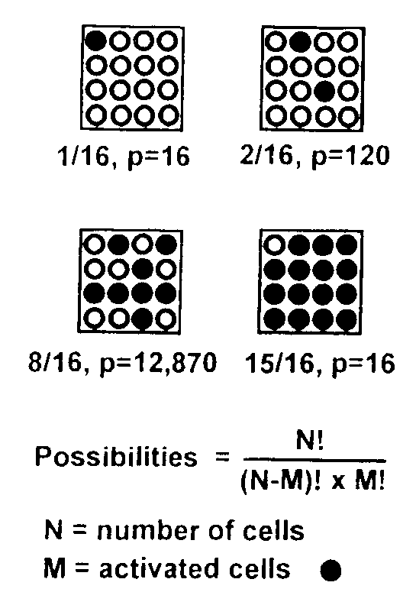

N-M = non-activated cell = 

Figure 2.7 Matrix showing the mathematical power of the 50 percent response rate. A darkened circle could represent a responding neuron, while an open circle could represent a nonresponding neuron. For very large N, if M is approximately one half of N (and M ~ N-M), the number of possibilities is about 2^{N}.

Independent of potentially complex temporal response patterns of cortical neuron ensembles, the massively parallel anatomical architecture of the cortical system provides great power for storing and recognizing images using a vector convolution and correlation approach (Murdock, 1982). In this construct, each neuron’s response represents a component of the vector occupying a huge N-dimensional abstract mathematical space, with N representing the number of neurons in the brain. In this model, the total number of potentially encodable environmental configurations equals 2 to the Nth power (see figure 2.7; for a 50% neuron response rate in an active field, M would approximate 1/2 of N, and for large N, the number of possibilities approaches 2 to the Nth power, still a satisfactorily large number). Recent studies have supported the concept that memories of details about the various attributes of a discrete visual object are stored in a distributed fashion in the respective multiple regions responsible for the sensory analysis and perception of those specific attributes (Ungerleider, 1995). This approach for storing information at the neuronal level can be viewed as a vector convolution operation (Murdock, 1982), using the NMDA receptor (McClelland et al., 1980) or other long-term potentiating mechanisms, and involving the establishment of new connections between different neuronal systems (Alkon, 1989), as well as the altering of the efficiency of existing synaptic connections to change their weighting. Recognition occurs if there is a significant correlation between the vector of a perceived image and the vector which describes the current state of the cerebral system.
The implications of this model of reciprocal, hierarchical information processing can be examined in the monkey in the visual processing pathway. Early electrical activity in the cortex (as early as 20 ms in the monkey cortex in response to a flash, but over 40 ms for a discrete visual detail) represents initial visual processing. Unit and field responses can be modified by alertness (e.g., Arezzo, Pikoff, & Vaughan, 1975) and attention to specific detail (Ashford & Fuster, 1985; Maunsell, 1995), as field potentials in the 200 ms latency neighborhood are in the human. The initial neuronal response suggests that information about the visual stimulus is carried both to the primary visual processing area to begin detailed analysis, and more widely to the entire visual system where it serves an alerting function, preparing the larger system for the synchronous and reciprocal analysis of visual information between the primary, secondary, and associational sensory processing areas and the medial temporal lobe. Electrical signals corresponding to selective attention, the analysis of discrete stimulus features, and the detection of a variety of types of unexpected events can be recorded from both primates and humans. For example, in the human, recognition of information as discordant from expectation (Donchin, 1981) or containing details which are to be retained (Fabiani, Karis, & Donchin, 1986) will generate a late positive electrical signal (P300, positivity at 300 ms), which is likely to indicate that the cortex has perceived the incoming information and has initiated a storage operation on the perceived information (Fabiani, Karis, & Donchin, 1990). While much of the work on gross electrical activity following environmental events has been done using electrical recordings from scalp electrodes in the human, studies in monkeys have shown comparable gross electrical events, while also allowing microelectrode analysis of concurrent local activity in deep brain structures. Microelectrode analysis has shown, for example, that the P300 is not just localized to the temporal lobe (Paller, Zola Morgan, Squire, et al., 1988), further supporting the concept that information processing occurs over broad cortical regions, probably using a parallel distributed processing mode. Work with monkeys looking at the responses of single neurons to behaviorally relevant stimulus dimensions shows the relationship between individual neuronal activity and cognition and also gives direct evidence that a single neuron can participate in a variety of functional networks (Fuster, 1995). Furthermore, these functional networks are wide-spread (Goldman-Rakic, 1988) and can adapt to task (i.e., environmental) demands over short periods of time (Bayliss & Rolls, 1987).
With regard to detail memory function, two systems have been identified in the monkey (Mishkin, 1982), one involving the hippocampus and Papez circuit through the anterior nucleus of the thalamus and the cingulate cortex (Papez, 1937), and the other involving the amygdala and the Nauta circuit through the dorsomedial nucleus of the thalamus and the orbitofrontal cortex (Nauta, 1971). The hippocampus seems to involve place memory (O’Keefe & Nadel, 1978), and recent studies suggest that hippocampal neurons in the monkey code for specific geographic directions which can be associated with visual information for storage organization (O’Mara, Rolls, Berthoz, et al., 1994; Ono, Nakamura, Nishijo, et al., 1993; Rolls, Robertson, & Georges-Francois, 1995). In contrast, the amygdala codes for emotions, including fear (in rodents; LeDoux, 1995; Killcross, Robbins, & Everitt, 1997) and alimentary, emotional (in dogs: Fonberg, 1969), sexual (in monkeys: Kling & Steklis, 1976), and social factors (in monkeys: Brothers & Ring, 1993), and these factors can also serve to index visual information for retrieval (LeDoux, 1994, 1995). Classic studies of monkeys with lesions of the amygdala revealed disruptions of social behavior (Kling & Steklis, 1976; Pribram, 1961; Rolls, 1995) deriving from failures to perceive or retain social cues relating to dominance or sexual hierarchies. The visual cortex connects broadly with the hippocampus (Van Hoesen & Pandya, 1975a,b; Van Hoesen, Rosene, & Mesulam, 1979; Rosene & Van Hoesen, 1987), allowing the hippocampus to facilitate information storage throughout the visual cortex (Ungerleider, 1995). However, only the anterior portion of the temporal cortex connects with the amygdala (Krettek & Price, 1977; Turner, Mishkin, & Knapp, 1980; Mishkin & Aggleton, 1981), allowing the amygdala to focus on facilitation of the analysis, encoding, and retention of more abstract visual information, particularly that information related to function such as food and sexual appeal and poison and danger signals. This model is consistent with electrical stimulation experiments with the human amygdala which evoke memories associated with emotions (Penfield, 1958).

Auditory System
The auditory system of the monkey is considered to process information using principles akin to those of the visual system (see figure 2.5). While it has been more difficult to train monkeys to perform tasks in response to auditory information, neurons of the auditory cortex are particularly responsive to the vocalizations of other monkeys. Further, there are multimodal cells between the visual and auditory regions within the temporal cortex.

Somatosensory System
The somatosensory system analyzes information in the parietal cortex, but in close association with the motor system and the frontal cortex anterior to the central sulcus (Pandya & Kuypers, 1969; Jones & Powell, 1970; Pandya & Yeterian, 1985) (see figure 2.5). The parietal cortex shows neuronal responses when monkeys perform touch discrimination tasks that are com parable to visual discrimination tasks. In a haptic delayed match-to-sample task (a tactile discrimination task with a delay), neurons in rhesus primary somatosensory cortex (SI) exhibit memory properties by firing during the delay. Also, units in monkey parietal association cortex discharge during perception and mnemonic retention of tactile features (Zhou & Fuster, 1992).

THE FRONTAL LOBE AND ATTENTION AND ACTIVE MEMORY SYSTEMS
Historically, there has been considerable effort to define the systems of the frontal lobe, particularly with regard to attention, thought, and decision- making processes. The “working memory” concept was introduced by Carlyle Jacobsen (1935) to explain the effects of principal sulcus lesions in monkeys, and was later shown to apply only to visuospatial tasks. Lesions of the inferior prefrontal convexity interfere with delayed response tasks, whether or not there is a spatial component, by decreasing the ability to inhibit incorrect responses. Lesions of the arcuate concavity leave delayed response behavior unaffected, but decrease the ability to choose between specific responses when presented with specific stimuli. Orbitofrontal lesions reduce emotionality and emotional arousal. This last finding led Egas Moniz to attempt the treatment of psychiatric patients with prefrontal lobotomy. Patients with prefrontal lobotomy show an inability to change response strategies on the Wisconsin Card Sorting test (Milner, 1974), which appears to be the same inhibition deficit seen in monkeys with inferior frontal convexity lesions. However, these patients show little diminishment on measures of intelligence. Thus, an important function of the frontal lobes appears to be weighing the consequences of various actions, and selection of some actions with the inhibition of others, within the repertoire of all learned or possible behaviors.
The frontal cortex manages information by coordinating activity in the sensory and perceptual regions posterior to the central sulcus. The frontal cortical regions form a functional executive network with the dorsomedial nucleus of the thalamus and the basal ganglia (Alexander, DeLong, & Crutcher, 1992) to generate smooth motor acts (Komhuber, 1974) and behavioral sequences (Fuster, 1997b), which include thinking and planning (Matthysse, 1974). The frontal cortex makes reciprocal connections with both the ventral and dorsal visual pathways as well as the auditory and somatosensory systems (see figure 2.5). Neurons in the frontal regions are active during tasks requiring visual attention, particularly during the period when short-term retention of information is required for spanning a delay interval before a response can be produced (Fuster, 1973). The prefrontal cortex can selectively analyze face information (0 Scalaidhe, Wilson, & Goldman-Rakic, 1997) and integrate the detail and spatial information analysis performed by the posterior cortical regions (Rao, Rainer, & Miller, 1997). Presumably, the prefrontal cortex serves to organize and sequence responses in posterior perceptual regions (Goldman-Rakic, 1988; Fuster, 1997b). In this fashion, the frontal cortex participates in the attentive aspects of perception and active short-term memory, also referred to as “working memory” (Goldman-Rakic, 1995), as well as facilitating the encoding of relevant: infor mation and orchestrating retrieval from long-term storage (Fuster, 1995, 1997a).

Development of Monkey Tasks for Attention and Active Memory
The early paradigms which were developed for testing behavior in the monkey used tasks such as delayed alternation. As an example of this task, the monkey might be required to push one button, then several seconds later, push a different button. Behavior in such tasks is impaired by lesions of the frontal lobes. Early explanations of the cognitive requirements for performing this task focused on memory. However, the performance of this task and others like it are more dependent on attention, or active short-term memory, than the long-term storage of information (Fuster, 1997b).
In a modification of the delayed alternation task, the delayed match-to- sample task, the correct button choice depends on matching to a previously displayed sample (see figure 2.6). In this task, it is clear that: it is attention to detail, then maintaining in an active state an internal representation of that now-absent sample stimulus image, which is critical to correct performance. Further studies of the brain regions involved in performance of this task have shown that the inferior temporal lobe is required for the analysis of the information detail component of the task. However, performance of the match when a significant delay is introduced depends on the frontal lobes, indicating that the capability of maintaining attention over time to an internal mnemonic representation of the stimulus detail is critically dependent on frontal lobe function. This dichotomy also demonstrates the behavioral interaction between the temporal and frontal lobes (Fuster, 1997b).

Tasks to Distinguish Active Memory and Retentive Memory
A critical issue in the understanding of memory function was the development of tasks which would demonstrate the storage of information after distraction (beyond the limits of attention, active short-term memory, or “working memory”). An important early demonstration by Gaffan (1977a,b) showed that monkeys could perform recognition tasks involving complex pictures, multiple colors, and multiple spatial positions. Gaffan also demonstrated that the fornix (see figure 2.2), presumably because of its critical anatomical role in connecting the basal forebrain to the hippocampus, was critical to the function of retentive memory, a form of memory frequently impaired in human amnesic patients (Scoville & Milner, 1957).
The role of the medial temporal lobe was further clarified by Mishkin (1982) using the delayed non-match-to-sample task with trial unique objects. This task showed impairment from medial temporal lobe lesions or cholinergic inhibitors, which both produce pronounced deficits of long-term memory in humans. For example, in the case of H.M., who had surgical ablation of both medial temporal lobes for epilepsy control, he is profoundly impaired in the ability to acquire most forms of new information, but can recall information learned prior to the surgery, and he can learn new motor skills (Scoville & Milner, 1957). In Mishkin’s initial experiments, lesions of either the hippocampus or amygdala impaired the performance of this task, and lesions of both systems rendered the monkey incapable of retaining the critical information. Later studies by Mishkin’s group suggested that the rhinal cortex, which is close to both the amygdala and hippocampus but proj ects more widely, plays the most pivotal role in the retention of information (Meunier, Bachevalier, Mishkin, et al., 1993). Of note, the rhinal cortex includes the entorhinal cortex, which is the region of the human brain that seems to be the initial site of attack of the Alzheimer’s process (Braak & Braak, 1991).
More recently, efforts have been made to computer-automate memory tasks for monkeys so that a computer screen can deliver the stimuli, and responses can be registered using a joystick or touch-screen technology. Use of a joystick keeps the animal’s hand out of the visual field, which is important since the hand itself can represent a visual stimulus. Computer control of response-reward contingencies allows teaching of considerably more complex tasks. For example, rhesus monkeys can be taught to read and associate responses with individual letters of the alphabet and retain those associations for up to an hour (figure 2.8) (Ashford & Edwards, 1991). Accordingly, such tasks can be used to test reaction times and brain wave components, and both are comparable to human measures. Also, memory tasks can be applied to other modalities, such as the sensorimotor system (Murray & Mishkin, 1984; Zhou & Fuster, 1992).
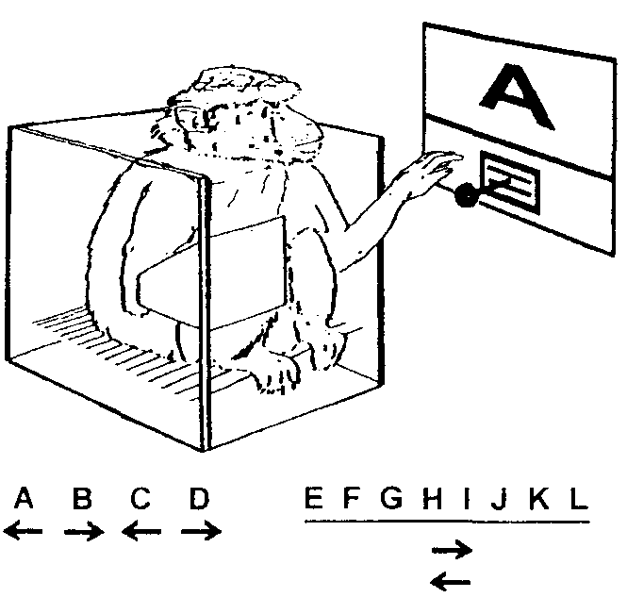
Figure 2.8 Monkey reading letters and performing joystick responses (Ashford & Edwards, 1991). The monkey could push the joystick to either the left or right. This task was taught to the monkey by reinforcing responses with sweetened juice rewards, the letters A, B, C, D always required the same direction for reward. However, the remaining eight letters were associated with a different pattern of correct directions each day. One monkey could learn each of these letters after a single trial (reward would mean correct direction; no reward would mean that the other direction was correct). Then it could recall the correct pattern for the letters, often flawlessly, after up to a half-hour delay, interspersed with trials of the other letters.

RELATION BETWEEN PROCESSING CAPABILITIES AND ENERGY REQUIREMENTS
In the course of understanding the relations between the volume of the cerebral cortex, information-processing power, and the need for energy- providing nutrients, the focus of attention must be on the neuron with its dendritic and axonal processes. There are about 50,000 pyramidal neurons under each square millimeter of cortical surface area. Each neuron may have up to 100,000 inputs arranged along a dendritic tree which may extend over 6 mm in many directions. Its axon has a comparable number of outputs which may extend as far as the base of the spinal cord, but commonly several centimeters to a target cortical region. The surface area of a pyramidal neuron may average I mm but may reach 1 cm Therefore, the total neuronal membrane surface area under a square millimeter of cortex surface is about 50,000 mm This equals about 10,000 m for the 2000 cm of the human cortex. About 40 percent of the metabolism of the brain is devoted to maintaining the resting potential across this huge amount of neuronal surface membrane. The remainder of brain metabolism is devoted to active cell activity (Magistretti & Pellerin, 1996), 10 percent for recovering from action potentials and 50 percent for synaptic activity. The brain consumes 20 per cent of the energy resources of the body; maintaining cerebral function is clearly a major energy cost to the individual.
If a single unique stimulus were coded by a single neuron, the brain would indeed be quiet, and the demands of repolarization and synaptic activity would be minimized. However, the stimulated neuronal assemblies, whether they are hard-wired primary cortical connections or plastic networks in association cortex, include large proportions of the cortical neurons. Observations of monkey cortical units responding to relevant stimuli suggest that a functional network of about half of the neurons in a field can manifest a response to a stimulus and that individual neurons may respond with several discharges to a single stimulus (Ashford & Fuster, 1985; Coburn et al., 1990; Mikami et al., 1994; Nakamura et al., 1994). During intense neuronal activity neurons depolarize frequently, creating a major metabolic expense in repolarization demand. The large proportion of cerebral cortex that is activated by environmental stimuli demands a heavy supply of energy, particularly in the primate (Armstrong, 1983). The physiological demands of processing in relation to cognition on a regional cortical basis can be visualized clearly by techniques which measure local cerebral blood flow (single photon emission computed tomography and functional magnetic resonance imaging) and metabolism (positron emission tomography). However, when the brain does achieve its maximum processing power, it may also achieve its point of
optimal processing efficiency and actually minimize its metabolic demand (Parks et al., 1989).
One important question is, How do neurons in the brain stem regulate the activity of neuronal ensembles in the cortex? (Woolf, 1996). For example, acetylcholine neurons project to limited cortical patches as small as a few square millimeters (Saper, 1984; Wainer & Mesulam, 1990), presumably calling them into action for relevant processing requirements. Serotonin neurons, whose processes are the most widely distributed in the brain, presumably activate broad regions of the cortex during a variety of waking behaviors (Jacobs & Azmitia, 1992). In relation to neural network models, catecholamines may play a unique role describable as adjusting the gain of logistic activation functions in the network (Servan-Schreiber & Cohen, 1992). Thus, the projections from the brain stem seem to play the role of efficiently orchestrating the processing of the distributed neural networks to assimilate and respond to the environment.

DEVELOPMENT OF INFORMATION-PROCESSING CAPACITY
In early development, primary cortical regions undergo critical periods when environmental input directs the formation of neuronal connections (Hubel & Wiesel, 1977) and the development of functional assemblies (Singer, 1995b). Higher-order association (e.g., perceptual) regions also pass through critical periods of time early in life (Webster, Bachevalier, & Ungerleider, 1995). In one example, neonatal damage to the inferior temporal cortex of the monkey was nearly fully compensated, as measured by multiple memory tasks in four- to five-year-old animals (Malkova, Mishkin, & Bachevalier, 1995). Yet, while the primary regions become relatively hard-wired early in life, higher- order association perceptual regions appear to retain some plasticity, forming new connections to accommodate the learning of new information throughout life (Diamond, 1988; Singer, 1995a) or until disabled by injury or a neurodegenerative process (Ashford, Shan, Butler, et al., 1995). By contrast, the medial temporal region, which is more primitive in its development, does not seem to be able to recover from injury at either early or late stages of life (Malkova et al., 1995). The frontal cortex seems to function less than optimally in immature animals (as the adjective implies when referring to human childlike behavior), but this region undergoes a critical period in humans with massive changes in connections in late adolescence and early adulthood (Feinberg, 1987). Subsequent to this, less flexibility (e.g., for personality change) is present.
As applied to neural networks, most cortical regions seem to have an early quiescent period, followed by a critical period in which the network under goes intense learning and revision of connections, followed by maturity, after which the region achieves a particular pattern of function that is less modifiable. However, some brain regions, such as the middle temporal lobe and the inferior parietal lobe, may retain high levels of plasticity throughout the animal’s life and maintain maximum ability to store complex information. (This maintained elevated level of plasticity may predispose these brain regions to the pathological changes seen in Alzheimer’s disease; Ashford & Zec, 1993; Ashford et al., 1995). It is the task of the whole brain working in concert to perceive the environment, analyze relevant information, store critical new information, and develop plans for the future which facilitate the survival and reproductive success of the organism in a complex world. The important aspect of development is the formation of connectivities and the coordination of processing within and between brain regions.

FUTURE PRIMATE MODELS FOR NEUROPSYCHOLOGY AND NEURAL NETWORKS
A central theme of this chapter is the value of nonhuman primates as models of human cognitive processes. Important information about human cognition has been obtained from human studies, such as brain imaging and recording brain electrical activity from scalp electrodes. However, such studies are limited in the amount they can tell us about the structural substrates of information processing. When functional principles and more details are needed, valuable information can be obtained from animal studies. In humans, there is a constant challenge to study ever smaller and deeper components of neuronal networks. Animal research extends the inquiry to progressively more basic levels. Studies of animals provide meaningful answers to questions about human brain structure and function. Moreover, comparative analysis can reveal clues to the development of functions.
The approach of studying the brain of a monkey performing a cognitive task will continue to be a valuable model for neuroscience. Monkeys appear to enjoy playing simple video games for extended periods of time, as do humans, and those games can be designed to test the capabilities of the animals. Brain function can be monitored using minimally invasive electrode recordings or scanning techniques. Perturbations can include administration of drugs with reversible effects or transient lesions such as those achieved by cooling. Using such approaches, the role of specific brain structures, chemical systems, and neuropsychological functioning can be explored relatively noninvasively in nonhuman primates.
An important future direction is the better understanding of how so many neurons work together within specific brain regions and across many different brain regions. Implantation of multiple indwelling electrode arrays, which can be monitored in concert with imaging procedures, and massive computer analysis of the interactions between the individual neurons, regional activations, and complex behavior, will reveal more information about how the brain functions in health and disease. The development of neural network and massive parallel distributed processing models based on empirical data obtained from across the primate order perhaps will reveal insights into human brain function that will transcend models developed using computers, lower animals, or humans alone.

REFERENCES
Abeles, M., Prut, Y., Bergman, H., & Vaadia, E. (1994). Synchronization in neuronal transmission and its importance for information processing. Progress in Brain Research, 102, 395—404.
Alexander, G.E., Delong MR., & Crutcher. M.D. (1992). Do cortical and basal ganglia motor areas use “motor programs” to control movement? Behavioral Brain Research, 15, 656—665.
Alkon, D. L. (1989). Memory storage and neural systems. Scientific American, July, 42—50. Allison, T., & Cicchetti, D. V. (1976). Sleep in mammals: Ecological and constitutional correlates. Science, 194, 732—734.
Allman, J. (1982). Reconstructing the evolution of the brain in primates through the use of comparative neurophysiological and neuroanatomical data. In E. Aimstrong, & D. Flak (Eds.), Primate brain evolution: Methods and concepts (pp. 13—28). New York: Plenum Press.
Allman, J. (1990). Evolution of neocortex. In E. G. Jones, & A. Peters (Eds.), Cerebral cortex, Vol. 8A (pp. 269—283). New York: Plenum Press.
Arezzo, J., Pikoff, A., & Vaughan, H. G. (1975) The sources and intracerebral distribution of auditory evoked potentials in the alert rhesus monkey. Brain Research, 90, 5 7—73.
Armstrong, E. (1983). Relative brain size and metabolism in mammals. Science, 220, 1302—1304.
Ashford, J. W. (1984). Cortical electrophysiology of visual encoding in the monkey. Ph.D. dissertation. Ann Arbor, Ml: University Microfilms International.
Ashford, J. W., & Edwards, H. (1991). Memory in the monkey: An automated paradigm and the effect of nicotine. Society for Neuroscience Abstracts, 17, 1236.
Ashford, J. W., & Fuster, J. M. (1985). Occipital and inferotemporal responses to visual signals in the monkey. Experimental Neurology, 90, 444—466.
Ashford, J. W., Shan, M., Butler, S., Rajasekar, A., & Schmitt, F. A. (1995). Temporal quantification of Alzheimer’s disease severity: “Time index” model. Dementia, 6, 269—280.
Ashford, J. W., & Zec, R. F. (1993). Pharmacological treatment in Alzheimer’s disease. In
R. Parks, R. Zec, & R. Wilson (Eds.), Neuropsychology of Alzheimer’s disease and other dementias
(pp. 589—614). New York: Oxford University Press.
Axel, R. (1995). The molecular logic of smell. Scientific American, October, 154—159.
Bailey, C. H., & Kandel. E. R. (1995). Molecular and structural mechanisms underlying long-term memory. In M. S. Gazzaniga (Ed.), The cognitive neurosciences (pp. 19—36). Cambridge. MA: MIT Press.
Bair, W., Koch, C., Newsome, W., & Britten, K. (1994). Power spectrum analysis of bursting cells in area MT in the behaving monkey. Journal of Neuroscience, 14, 2870—2892.
Baylis. G. C., & Rolls, E. T. (1987). Responses of neurons in the inferior temporal cortex in short term and serial recognition memory tasks. Experimental Brain Research, 65, 614—622.
Baylis, C. C., Rolls. E. T.. & Leonard, C. M. (1987). Functional subdivisions of the temporal lobe neocortex. Journal of Neuroscience, 7, 330—342.
Benevento, L. A., & Rezak, M. (1976). The cortical projections of the inferior pulvinar and adjacent lateral pulvinar in the rhesus monkey (Macaca mulatto): An autoradiographic study. Brain Research, 108, 1—24.
Berger, R. J. (1975). Bioenergetic functions of sleep and activity rhythms and their possible relevance to aging. Federation Proceedings. 34, 97—102.
Bermudez-Rattoni, F., Coburn, K. L., Fem J., Chavez, A. F., & Garcia, J, (1987). Potentiation of odor by taste and odor aversions in rats are regulated by cholinergic activity of dorsal hippocampus. Pharmacology, Biochemistry and Behavior, 26, 553—559.
Braak, H., & Braak, E. (1991). Neuropathological staging of Alzheimer-related changes. Acta
Neuropathology, 82, 239—259.
Bressler, S. L. (1995). Large-scale cortical networks and cognition. Brain Research Reviews, 20,
288—304.
Bressler, S. L., Coppola, R., & Nakamura, R. (1993). Episodic multiregional cortical coherence at multiple frequencies during visual task performance. Nature, 366, 153—156.
Brothers, L., & Ring, B. (1993). Mesial temporal neurons in the macaque monkey with responses selective for aspects of social stimuli. Behaviovral Brain Research, 57, 53—61.
Cinelli, A. R., Hamilton, K. A., & Kauer, J. S. (1995). Salamander olfactory bulb neuronal activity observed by video rate, voltage-sensitive dye imaging. III. Spatial and temporal properties of responses evoked by odorant stimulation. Journal of Neurophysiology. 73, 205 3—2070.
Coburn, K. L., Ashford, J. W., & Fuster, J. M. (1990). Visual response la in temporal lobe
structures as a function of stimulus information load. Behavioral Neuroscience, 104, 62—73.
Coburn, K. L., Garcia, J., Kiefer, S. W., & Rusiniak, K. W. (1984). Taste potentiation of poisoned odor by temporal contiguity. Behavioral Neuroscience, 98, 813—819.
Desimone, R. (1991). Face-selective cells in the temporal cortex of monkeys. Journal Cognitive Neuroscience, 3, I—S.
Desimone, R., Aibright, T. D., Gross, C. G., & Bruce, C. (1984). Stimulus-selective properties of inferior temporal neurons in the macaque. Journal of Neuroscience, 4, 2051—2062.
Desimone, R., & Gross, C. G. (1979). Visual areas in the temporal cortex of the macaque. Brain Research, 178, 363—380.
Diamond, M. C. (1988). Enriching heredity. New York: The Free Press.
Donchin, E. (1981). Surprise? ... Surprise! Psychophysiology, 18, 492—513.
Eskandar, E. N., Richmond, B. J., & Optican, L. M. (1992). Role of inferior temporal neurons in visual memory, I. Temporal encoding of information about visual images, recalled images, and behavioral context. Journal of Neurophysiology, 68, 1277—1295.
Fabiani, M., Karis, D., & Donchin, E. (1986). P300 and recall in an incidental memory paradigm. Psychophysiology, 23, 298—308.
Fabiani, M., Karis, D., & Donchin, E. (1990). Effects of mnemonic strategy manipulation in a Von Restorff paradigm. Electroencephalography and Clinical Neurophysiology, 75, 22—35.
Feinberg, 1. (1987). Adolescence and mental illness. Science, 236, 507—508.
Felleman, D. J., & VanEssen, D. C. (1991). Distributed hierarchical processing in the primate cerebral cortex. Cerebral Cortex, 1, 1—15.
Ferster, D., & Spruston, N. (1995). Cracking the neuronal code, Science, 270, 756—757.
Fonberg, E. (1969). The role of the hypothalamus and amygdala in food intake, alimentary motivation and emotional reactions. Acta Biologica Experimentia, 29, 335—358.
Freeman, W. 1. (1987). Simulation of chaotic EEG patterns with a dynamic model of the olfactory system. Biological Cybernetics, 56, 139—150.
Freeman, W. J.. & Skarda. C. A. (1985). Spatial EEG patterns, non-linear dynamics and perception: The neo-Sherringtonian view. Brain Research Reviews, 10. 147—175.
Fuster, 1. M. (1973). Unit activity in prefrontal cortex during delayed-response performance:
Neuronal correlates of transient memory. Journal of Neurophysiology, 36, 61—78.
Fuster, J. M. (1995). Memory in the cerebral cortex: An empirical approach to neural networks in the human and nonhuman primate. Cambridge. MA: MIT Press.
Fuster, J. M. (1997a). Network memory. Trends in Neurosciences, 20, 451—459.
Fuster, J. M. (1997b). The prefrontal cortex: Anatomy, physiology and neuropsychology of the frontal lobe, 3rd ed. New York: Raven Press.
Gaffan, D. (1977a). Monkeys’ recognition memory for complex pictures and the effect of fornix transection. Quarterly Journal of Experimental Psychology, 29, 505—514.
Gaffan, D. (1977b). Recognition memory after short retention intervals in fornix-transected monkeys. Quarterly Journal of Experimental Psychology, 29, 5 77—588.
Gawne, T. J., & Richmond, B. J. (1993). How independent are the messages carried by adjacent inferior temporal cortical neurons? Journal of Neuroscience, 13, 2758—2771.
Goldman-Rakic, P. S. (1988). Topography of cognition: Parallel distributed networks in primate association cortex. Annual Review of Neuroscience. 11, 137—156.
Goldman-Rakic P. S. (1995). Cellular basis of working memory. Neuron, 14, 477—485.
Gratton, A., & Wise, R. A. (1988). Comparisons and refractory periods for medial forebrain bundle fibers subserving stimulation-induced feeding and brain stimulation reward: a psychophysical study. Brain Research, 438, 256—263.
Haberly, L. B., & Bower, j. M. (1989). Olfactory cortex: Model circuit for study of associative memory? Trends in Neuroscience, 12, 258—264.
Hayek, F. A. (1952). The Sensory Order: An inquiry into the foundations of theoretical psychology. Chicago: University of Chicago Press.
Hubel, D. H., & Wiesel, T. N. (1977). Functional architecture of macaque monkey visual cortex. Proceedings of the Royal Society of London, Series B, 181, 1—59.
Jacobs, B. L., & Azmitia, F. C. (1992). Structure and function of the brain serotonin system. Physiological Reviews, 72, 165—229.
Jacobsen, C. F. (1935). Functions of frontal association areas in primates. Archives of Neurology and Psychiatry, 33, 558—569.
Jerison, H. J. (1991). Brain size and the evolution of mind. New York: American Museum of Natural History.
John, E. R. (1972). Switchboard versus statistical theories of learning and memory. Science, 177, 850—864.
Jones, E. G. (1990). Modulatory events in the development and evolution of primate neocortex. In E. G. Jones and A. Peters (Eds.). Cerebral cortex, Vol. 8A (pp. 3 11—362). New York: Plenum Press.
Jones, F. G., & Powell, T. P. 5. (1970). An anatomical study of converging sensory pathways within the cerebral cortex of the monkey. Brain, 93, 793—820.
Kaba, H., Hayashi, Y., Higuchi, T., & Nakanishi, S. (1994). Induction of an olfactory memory by the activation of a metabotropic glutamate receptor. Science, 265, 262—264.
Karten, F J. (1991). Homology and evolutionary origins of the “neocortex.” Brain Behavior and Evolution, 38, 264—272.
Kauer, J. S. (1991). Contributions of topography and parallel processing to odor coding in the vertebrate olfactory pathway. Trends in Neuroscience, 14, 79—85.
Killackey, H. P. (1995). Evolution of the human brain: A neuroanatomical perspective. In M. S.
Gazzaniga (Ed.), The cognitive neuro5cieflCes (pp. 1243—1253). Cambridge, MA: MIT Press.
Killcross S.. Robbins, T. W., & Everitt, B. J. (1997). Different types of fear-conditioned behavior mediated by separate nucleii within amygdala. Nature, 388, 377—380.
Kling, A., & Steklis, H. D. (1976), A neural substrate for affilliative behavior in nonhuman primates. Brain Behavior and Evolution, 13, 216—238.
Kornhuber, H. H. (1974). Cerebral cortex, cerebellum, and basal ganglia: An introduction to their motor functions. In F. 0. Schmitt & F. C. Worden (Eds.), The neurosciences. Third study program (pp. 267—280). Cambridge, MA: The MIT Press.
Ksettek, J. E., & Price, J. L. (1977). Projections from the amygdaloid complex to the cerebral cortex and thalainus in the rat and cat. Journal of Comparative Neurology, 172, 687—722.
Kuypers. H. G. J. M., Szwarcbart, M. K., Mishkin, M., & Rosvold, H. E. (1965). Occipitotemporal corticocortical connections in the rhesus monkey. E.rperi mental Neurology, 11, 245—262.
Lashley, K. S. (1950). In search of the engram. Symposium, Society for Experimental Biology, 4, 454—482.
Laurent, C. (1996). Odor images and tunes. Neuron, 16, 473—476.
LeDoux, J. E. (1994). Emotion, memory and the brain. Scientific American, June, 50—57. LeDoux, J. E. (1995). In search of an emotional system in the brain: Leaping from fear to emotion and consciousness. In M. S. Gazzaniga (Ed.), The cognitive neurosciences (pp. 1049—106 1). Cam bridge, MA: MIT Press.
Macko, K., Jarvis, C. D., Kennedy, C, Miyaoka, M., Shinohara, M., Sokoloff, L, & Mishkin, M.
(1982). Mapping the primate visual system with (2C14) deoxyglucose. Science, 281, 394—396.
Magistretti, P. J., & Pellerin, L. (1996). Cellular mechanisms of brain energy metabolism: Relevance to functional brain imaging and to neurodegenerative disorders. Annals of the New York Academy of Sciences, 777, 380—1387.
Malkova, L Mishkin, M., & Bachevalier, J. (1995). Long-term effects of selective neonatal tem poral lobe lesions on learning and memory in monkeys. Behavioral Neuroscience, 109, 2 12—226.
Matthysse, S. (1974). Schizophrenia: Relationships to dopamine transmission, motor control and feature extraction. In F. 0. Schmitt & F. G. Worden (Eds.). The neurosciences, Third 5tudy program (pp. 733—73 7). Cambridge, MA: The MIT Press.
Maunsell, J. H. R. (1995). The brains visual world: Representation of visual targets in cerebral cortex. Science, 2 70, 764—769.
McClelland, J. L., Rumeihart, D. B., & the PDP Research Group. (1986). Parallel distributed pro cessing: Explorations in the microstructure of cognition, vol. 2: Psychological and biological models. Cambridge, MA: MIT Press.
McClurkin, J. W., Optican. L. M., Richmond, B. J., & Gawne, T. J. (1991). Concurrent processing and complexity of temporally encoded neuronal messages in visual perception. Science, 253, 675—677.
Meunier, M., Bachevalier, J., Mishkin, M., & Murray, E. A. (1993). Effects on visual recognition of combined and separate ablations of the entorhinal and perirhinal cortex in rhesus monkeys. Journal of Neuroscience, 13, 54 18—5432.
Mikami, A., Nakamura, K., & Kubota, K. (1994). Neuronal responses to photographs in the superior temporal sulcus of the rhesus monkey. Behavioural Brain Research, 60, 1—13.
Mimer, B. (1974). Hemispheric specialization: Scope and limits. In F. 0. Schmitt, & F. G. Worden (Eds.), The neurosciences. Third study program (pp. 75—89). Cambridge, MA: MIT Press.
Mishkin, M. (1982). A memory system in the monkey. Philosophical Transactions of the Royal Society of London. Series B. 298, 85—95.
Mishkin, M., & Aggleton, J. (1981). Multiple functional contributions of the amygdala in the monkey. In Y. Ben-An (Ed.), The amygdaloid complex (pp. 409—420). Amsterdam: Elsevier.
Moruzzi, C., & Magoun, H. W. (1949). Brain stem reticular formation and activation of the EEG. Journal of Electroencephalography and Clinical Neurophysiology, 1, 455—473.
Murdock. B. B. (1982). A theory for the storage and retrieval of item and associative information. Psychological Review, 89, 609—626.
Murray, E. A., & Mishkin, M. (1984). Severe tactual as well as visual memory deficits follow combined removal of the amygdala and hippocampus in monkeys. Journal of Neuroscience, 4, 2565—2580.
Nakamura, K., Matsumoto. K., Mikami, A., & Kubota, K. (1994). Visual response properties of single neurons in the temporal pole of behaving monkeys. Journal of Neurophysiology, 71, 1206— 1221.
Nakamura, K,, Mikami. A., & Kubota, K. (1992). Activity of single neurons in the monkey amygdala during performance of a visual discrimination task Journal of Neurophysiology, 67, 1447—1463.
Nauta, W. J. H. (1971). The problem of the frontal lobe: A reinterpretation. Journal of Psychiatric Research, 8, 167—187.
Nauta, W. J. H., & Karten, H. J. (1970). A general profile of the vertebrate brain, with sidelights on the ancestry of the cerebral cortex. In F. 0. Schmitt, & F. G. Worden (Eds.), The neurosciences. Third study program (pp. 7—26). New York: Rockefeller University Press.
O’Keefe, J., & Nadel, L. (1978). The hippocampus as a cognitive map. New York: Oxford University Press.
O’Mara, S. M., Rolls, E. T., Berthoz, A., & Kesner, R. P. (1994). Neurons responding to whole-body motion in the primate hippocampus. Journal of Neuroscience, 14, 6511—6523.
Ono, 1., Nakamura, K., Nishijo, H., et al. (1993). Monkey hippocampal neurons related to spatial and nonspatial functions. Journal of Neurophysiology, 70, 15 16—1529.
O Scalaidhe, S. P., Wilson, F. A. W., & Goldman-Rakic, P. S. (1997). Areal segregation of face- processing neurons in prefrontal cortex. Science, 278, 1135—1138.
Paler, K. A., Zola-Morgan, S., Squire, L R., & Hillyard, S. A. (1988). P3-like brain waves in normal monkeys and in monkeys with medial temporal lesions. Behavioral Neuroscience, 102, 714—725.
Pandya. D. N., & Kuypers, H. (1969). Cortico-cortical connections in the rhesus monkey. Brain Research, 13, 13—36.
Pandya, D. N., & Yeterian, E. H. (1985). Architecture and connections of cortical association areas. In A. Peters, & E. C. Jones (Eds.), Cerebral cortex, 4, (pp. 3—61). New York: Plenum Press.
Papez, 1. W. (1937). A proposed mechanism of emotion, In R. L. lsaacson (Ed.), Basic readings in neuropsychology (pp. 87—109). Huntington, NY: Krieger.
Parks, R. W., Crockett. D. J,, Tuokko, H., Beattie, B. L., Ashford, J. W., Coburn, K. L., Zec, R. F., Becker, R. E., McGeer, P. L., & McGeer, F. C. (1989). Neuropsychological “systems efficiency” and positron emission tomography. Journal of Neuropsychiatry, 1, 2 70—282.
Parks, R. W., Levine, D. S., Long, D. L., Crockett, D. J., Dalton, I. E., Weingartner, H., Fedio, P., Coburn, K. L., Suer, C., Matthews, J. R., & Becker, R. E. (1992). Parallel distributed processing and neuropsychology: A neural network model of Wisconsin card sorting and verbal fluency. Neuropsychology Review, 3, 213—233.
Penfield, W. (1958). Functional localization in temporal and deep sylvian areas. Research Publish ing Association for Research in Nervous and Mental Disease. 36. 210—226.
Preuss, T. M. (1995). The argument from animals to humans in cognitive neuroscience. In M. S. Gazzaniga (Ed.), The cognitive neurosciences (pp. 1227—1241). Cambridge, MA: MIT Press.
Pribram. K. H. (1961). Limbic system. In D. E. Sheer (Ed.), Electrical stimulation of the brain (pp. 3 11—320). Austin: University of Texas Press.
Pribram, K. H. (1967). The limbic systems, efferent control of neural inhibition and behavior. Progress in Brain Research, 27, 318—336.
Rao, S. C., Rainer, C., & Miller, E. K. (1997). Integration of what and where in the primate prefrontal cortex. Science, 276, 82 1—824.
Robbins, T. W., & Everitt, B. J. (1995). Arousal systems and attention. In Gazzaniga, M. S. (Ed.), The cognitive neurosciences (pp. 703—720). Cambridge, MA: The MIT Press.
Rockland, K. S., & Pandya, D. N. (1979). Laminar origins and terminations of cortical con nections of the occipital lobe in the rhesus monkey. Brain Research, 179, 3—20.
Rolls, E. T. (1995). A theory of emotion and consciousness, and its application to understanding the neural basis of emotion. In M. S. Gazzaniga (Ed.), The cognitive neurosciences (pp. 1091—1106). Cambridge. MA: The MIT Press.
Rolls, E. T., Robertson, R. C., & Georges-Francois, P. (1995). The representation of space in the primate hippocampus. Society for Neuroscience Abstracts, 21, 1494.
Rolls, E. T., & Treves, A. (1994). Neural networks in the brain involved in memory and recall. Progress in Brain Research, 102, 335—341.
Rosene, D. L., & Van Hoesen, G. W. (1987). The hippocampal formation of the primate brain: A review of some comparative aspects of cytoarchitecture and connections. In F. C. Jones, & A. Peters (Eds.), Cerebral cortex, Vol. 6 (pp. 345—356). New York: Plenum Press.
Rubenstein, J. L. R., Martinez. S., Shimamura, K., & Puelles, L (1994). The embryonic vertebrate forebrain: The prosomeric model. Science, 266, 578—580.
Saper, C. B. (1984). Organization of cerebral cortical afferent systems in the rat. II. Magnocellular basal nucleus. Journal of Comparative Neurology, 222, 3 13—342.
Scoville, W. B., & Milner, B. (1957). Loss of recent memory after bilateral hippocampal lesions. Journal of Neurology, Neurosurgery and Psychiatry, 20, 11—21.
Sejnowski. T. J., Kienker, P. K., & Shepherd, G. M. (1985). Simple pattern recognition models of olfactory discrimination. Society for Neuroscience Abstracts, 11, 970.
Shepherd. C. M. (1994). Discrimination of molecular signals by the olfactory receptor neuron. Neuron, 13, 771—790.
Shepherd, C. M. (1995). Toward a molecular basis for sensory perception. In M. S. Gazzaniga (Ed.), The cognitive neurosciences (pp. 105—118). Cambridge, MA: MIT Press.
Servan-Schreiber, D., & Cohen. J. D. (1992, March). A neural network model of catecholamine modulation of behavior. Psychiatric Annals, 22, 125—130.
Singer, W. (1995a). Time as coding space in neocortical processing: A hypothesis. In Gazzaniga, M. S. (Ed.), The cognitive neurosciences (pp. 91—104). Cambridge, IVIA: MIT Press.
Singer. W. (1995b). Development and plasticity of cortical processing architechires. Science, 270, 758—764.
Singer, W., & Gray, C. M. (1995). Visual feature integration and the temporal correlation hypothesis. Annual Review of Neuroscience, 18, 555—586.
Singer, W., EngeL A. K.. Kreiter, A. D., Munk, M. H. J., Neuenschwander, S.. & Roelfsema. P. R. (1997). Neuronal assemblies: necessity, signature and detectability. Trends in Cognitive Sciences, 1, 252—261.
Tanaka, K., Saito, H. A., Fukada, Y., It Moriya, M. (1991). Coding visual images of objects in the inferotemporal cortex of the macaque monkey. Journal of Neurophysiology, 66, 170—188.
Tanaka. K. (1993). Neural mechanisms of object recognition. Science, 262, 685—688.
Trombley, P. Q., & Shepherd, C. M. (1993). Synaptic transmission and modulation in the olfactory bulb. Current Opinion in Neurobiology, 3, 540—547.
Turner, B. H., Mishkin, M., & Knapp, M. (1980). Organization of the amygdalopetal projections from modality-specific cortical association areas in the monkey. Journal of Comparative Neurology, 1991, 515—543.
Ungerleider, L. C. (1995). Functional brain imaging studies of cortical mechanisms for memory. Science, 270, 769—775.
Ungerleider, L. C.. & Mishkin, M. (1982). Two cortical visual areas. In D. J. Ingle, R. J. W. Mansfield, & M. A. Goodale (Eds.), Analysis of visual behavior (pp. 549—586). Cambridge. MA: MIT Press.
Van Essen, D. C., Anderson, C. H., & Felleman, D. J. (1992). Information processing in the pri mate visual system: An integrated systems perspective. Science, 255, 419—423.
Van Essen, D. C., & Deyoe, E. A. (1995). Concurrent processing in primate visual cortex. In M. S. Gazzaniga (Ed.), The cognitive neurosciences (pp. 383—400). Cambridge. MA: MIT Press.
Van Hoesen, C. W., It Pandya, D. N. (1975a). Some connections of the entorhinal (area 28) and perirhinal (area 35) cortices of the rhesus monkey. I. Temporal lobe afferents. Brain Research. 95, 1—24.
Van Hoesen. G. W., & Pandya. D. N. (1975b). Some connections of the entorhinal (area 28) and perirhinal(area 35) cortices of the rhesus monkey. III. Efferent connections. Brain Research, 95, 39—59.
Van Hoesen, G. W., Rosene, D. L., & Mesulam, M. M. (1979). Subicular input from temporal cortex in the rhesus monkey. Science, 205, 608—610.
Wainer, B. H., and Mesulam M. M. (1990). Ascending cholinergic pathways in the rat brain. In M. Steriade It D. Biesold (Eds.), Brain cholinergic systems (pp. 65—119). New York Oxford Uni versity Press.
Webster, M. J., Bachevalier, J., & Ungerleider, L. G. (1995). Transient subcortical connections of inferior temporal areas TE and TEO in infant macaque monkeys. Journal of Comparative Neurology, 353, 213—226.
Woolf, N. J. (1996). Global and serial neurons form a hierarchically arranged interface proposed to underlie memory and cognition. Neuroscience, 74, 625—651.
Zhou, Y., & Fuster, J. M. (1992). Unit discharge in monkey’s parietal cortex during perception and mnemonic retention of tactile features. Society for Neuroscience Abstracts, 18, 706.
ADDENDUM (Some comments on evolution edited out of the original chapter, at end of the section on the role of cortical information processing)

The evolutionary issues of brain development are of great importance in understanding cortical function, because it is the remnants of this lineage which provide the structural resources and constraints for humans. An important example of an evolutionary pattern retained by the human is the brain's requirement for appropriate stimulation for its normal development. The primary cortical regions need external sensory stimulation at critical periods for appropriate connections to form (evidence in monkeys; Hubel & Wiesel, 1977); early visual environment without horizontal lines, for example, will produce an adult visual system blind to such lines (Barlow, 1995). Feed-forward and reciprocal connections formed by coactivation of particular neurons by environmental stimulation are needed for the development of complex assemblies (in monkeys, Singer, 1995b). Essentially, the brain's sensory systems appear to optimize themselves during particular epochs of development ("critical periods") to analyze the specific types of information available in the environment. On a more complex level, research on monkeys has shown that social interactions are required to develop appropriate intraspecies behaviors (Harlow, 1975). Further, the more complex the environmental stimulation, the greater is the complexity of the dendritic trees in the cortex and the more complex the activities of the individual (Diamond, 1988). This pattern, stimulation required for development of complex structure, the information processing systems of the brain optimizing themselves to process the specific types of information in the organism's environment, is a fundamental theme of mammalian evolution through higher primates, and a clear indication of the importance of interaction between the individual and the environment in the process of development. This capacity of the cortex to expand and optimize itself to meet the demands of a competitive environment has been the successful stratagem favoring cortical evolution through several million years of ruthless natural selection.

DNA provides a blueprint for the construction of a basic neural system. However, environmental stimuli (including maternal-child interactions) are the means for adjusting the system for successful adaptation to the world and proper interactions with other members of the species. Critical information is imprinted or meticulously learned by the developing organism, with larger amounts of cortex required to learn greater quantities of (and relationships between) complex information. Longer periods of development allow both the growth of larger brains and integration of progressively greater amounts of information. This pattern reaches a peak in the human with the development of a large surface area of association cortex requiring years of learning for development of the individual into a fully cultured member of society (consider the works of Ashley Montague).

IX. CONCLUSION

The adult primate brain is capable of processing complex information in multiple sensory modalities and integrating that information across modalities to form abstract concepts, which can be stored for use at a later period. A principle in brain evolution is that systems tend to expand and take on progressively more complex functions, so that information can be analyzed at increasingly higher levels, both within modalities and across time. The largest evolutionary advances in this regard have been made in those species under the greatest survival pressure in geographical regions of the most abundance when adaptation was achieved by expanding the information processing capability. This line of development has occurred most dramatically in higher primates and reaches its present manifestation with the largest ratio of cerebral cortical surface area to body mass in man (Jerison, 1991).

The principal task of the brain is learning about the environment so that information can be organized and behavioral decisions made to foster the organism's survival. The way the brain goes about performing this task may be studied in considerable detail in the young primate. ….. However, it is the task of the whole brain working in concert to perceive the environment, analyze relevant information and plan for the future which facilitates the survival of the organism in this complex world.

